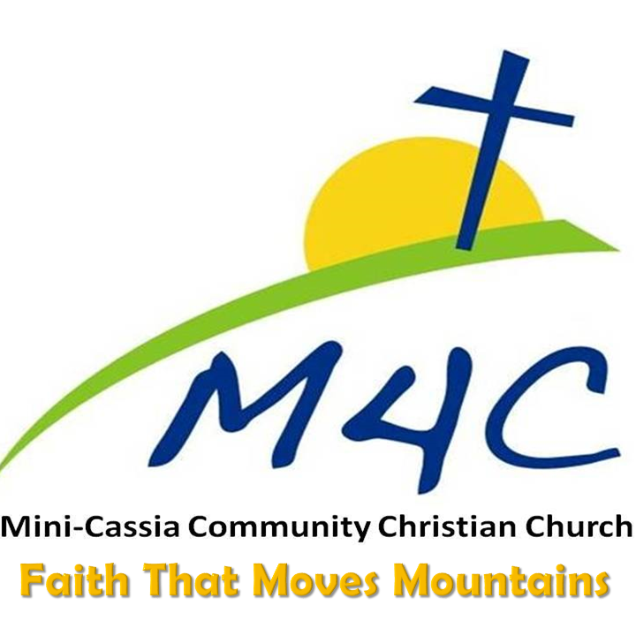

Hey M4C Family!

It was awesome to share and worship with you all yesterday and those who couldn’t join us, we missed you! As we talked about previously, these are interesting days we are living in but we know our Lord isn’t surprised by any of this. Now, more than ever our family, friends and neighbors need the hope and mercy of our Savior and I’m convinced we, as His Church have been called to be His hands and feet to share the light of His love.

We are monitoring the news and information being shared and will update you frequently regarding our scheduled groups and activities as the week unfolds. This is a very fluid situation and we desire to be wise and do our best for the safety and good of our M4C Family, our friends and neighbors and everyone else.

As I shared yesterday, please be aware and careful and if you have any concerns, please err on the side of caution. Keep in touch and let one of your M4C Family know if we can help you somehow.

I keep remembering what Mordecai said to Esther in Esther 4:14, “Who knows but that you have come your royal position for such a time as this?” May we depend on our Heavenly Father for the courage and strength to serve Him faithfully and fearlessly!

Please pray, help care for your family and friends and together, let’s let His love and light shine brightly through us all!

You are loved,

Pastor Andy

