WE WILL BE TAKING PHOTOS AND VIDEOS TO SHARE WITH THE CONGREGATION AND ON OUR WEBSITE. IF YOU DO NOT WISH YOUR STUDENTS TO BE FEATURED IN THESE PHOTOS PLEASE LET US KNOW.

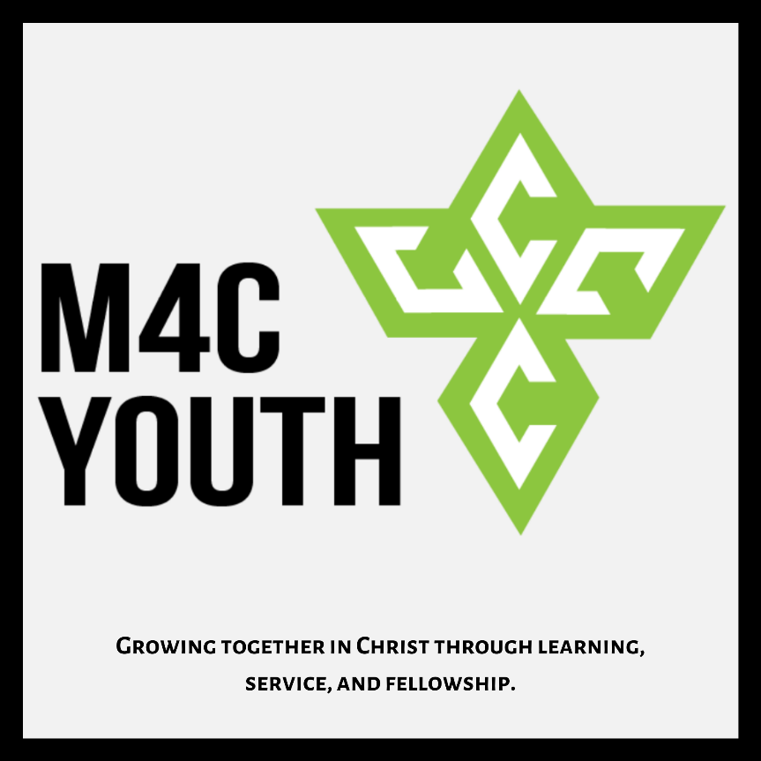

Youth group:

The first 3 Mondays of each month @ 6:30pm at the church.

6:30-6:45-Food and conversation.

6:45-7:30- Scripture lesson and discussion.

7:30-8:00- Games/hangout time.

Parents are more than welcome to stay and participate.

What We Learned:
Monday March 16th we looked at Matthew 16 where different groups that interacted with Jesus may have realized who He was (the Messiah), but did not accept it. The religious leaders kept on denying it, claiming that they needed more evidence. The Disciples were focused more on earthly worries. Peter makes the proclamation saying that Jesus is the Christ, but later tries to tell Jesus what that is supposed to look like. Finally Jesus makes it clear that anyone who wants to follow Him has to accept Him on His terms, not theirs. We may realize who Jesus is, but that has to be evident in how we live.
Memory Verse of the Month:
“But seek first His kingdom and His righteousness, and all these things will be added to you.” Matthew 6:33

COVID-19: We are exploring options for online lessons and small group discussions. Keep an eye out for an email from m4cnextgeneration@gmail.com for updates and details.
Please continue to pray for the leaders of our nation, states, cities, and churches as we navigate this odd time.

This Month
The Lock-In has been postponed until a later date. More details to come. Keep an eye out for a possible youth group hang out on that day.

A Few Months Out
We will be helping with the Easter egg hunt and crafts at Church on Easter Sunday. More details about that will be coming soon.
We will be building a Nine Square in the Air set up for youth and families to play.

Youth group is now the first 3 Mondays of each month.
We will have at least two teaching nights and a service night once a quarter. We will also be planning family hangout nights at least every other month.

All BBC events have been canceled for the time being.

We are looking for family volunteers to provide dinner for youth group whenever they can. If any families are interested just let Jacob know.

Summer Dates
June 13th-20th- SWAT High School Camp.
June 21st-26th- Junior High Camp (6th-8th).
June 28th-30th- First Chance Camp (2nd-3rd grade).
July 5th-10th – High School Camp (9th-12th).
July 12th-17th- Junior Camp (4th-5th grade).

Thank you for letting your family take part in youth group with us. We finish our lessons by 7:30-7:45pm and follow it up with a fellowship/hangout time until 8pm. If you would like to pick up your student earlier we wrap up the lesson by 7:30.

If you would like to learn more about what we are teaching, what events are coming up, or how you can get involved please feel free to reach out.

If you have any questions or concerns please feel free to text or call Jacob or Jenn.

Youth Leaders:
Jacob Hartman
Cell: (208)286-6433 Email: jah2334@gmail.com
Jenn McFarland
Cell: (208)670-1572

