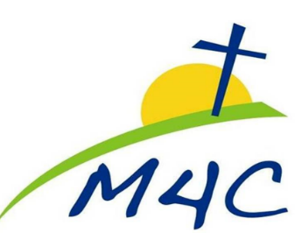
Dear M4C Family!

In light of the recent concerns world-wide about the COVID-19 virus, you need to know that our staff and elders are communicating regularly and monitoring the changing dynamics in our local area. As you know, we’re in a situation here that none of us have been in before and things are changing day by day. Here is the plan for M4C as of right now:

M4C WILL GATHER ON SUNDAY for Sunday School at 9:30am and Worship at 10:30am. We plan to stay open for Sunday services and our weekly activities will continue as scheduled. Again, we will keep watching the changing dynamics of this situation closely and communicate if there are changes through the Remind App, text messaging, the M4C Facebook page and at http://www.m4cchurch.org/

Nothing can take the place of worship and fellowship as the church. It's vital for our spiritual growth and well-being that we meet regularly (Hebrews 10:25). If for health or precautionary reasons you are unable to attend our services for any period of time, we encourage you to stay in community with the Church. We don't want to lose touch with anyone and we are working on increasing channels of communication with those who are most at risk…of flu, colds, etc. and of this new virus we are still learning about.

Please hear our hearts: There is nothing wrong with missing a week of church if you or someone in your family doesn’t feel well or you are concerned about going out in public during this unique time. God won’t love you any less if you take the week off and neither will we! Please keep in touch with us so we can help if needed.

As mentioned, we are working on setting up streaming of the Sunday message so you can watch online (more details on that soon) or posting a video soon after service if you or your loved ones are not feeling well, or at risk. Until then, we encourage you to listen to the Audio recordings of the morning message, generally posted on the church website: http://www.m4cchurch.org/ early Sunday afternoon.

We are committed to keeping M4C a clean space for you to worship. We are in this together. Here are ways you can help: Wash your hands often with soap and water; If you are feeling unwell, please rest at home; when coughing or sneezing, consider others and keep covered.

Pray and Trust!!! Pray for healing and successful treatments! Pray for World leaders, National leaders, Community and Local leaders for wisdom and guidance! Pray for Health Care providers and resources! Pray for calm and reasoned logic in the lives of our neighbors and fellow citizens; Pray that faithful followers can shine with the love, peace and light of Christ that shatters the darkness and hopelessness!

Pray with and for us as we seek to glorify our Lord and His church, shining as a light in the midst of the chaos and concerns of all.

Pastor Andy and the Leadership Team at M4C
M4C (Mini-Cassia Community Christian Church) 720 J Street, Heyburn, Idaho 83336

