WE WILL BE TAKING PHOTOS AND VIDEOS TO SHARE WITH THE CONGREGATION AND ON OUR WEBSITE. IF YOU DO NOT WISH YOUR STUDENTS TO BE FEATURED IN THESE PHOTOS PLEASE LET US KNOW.

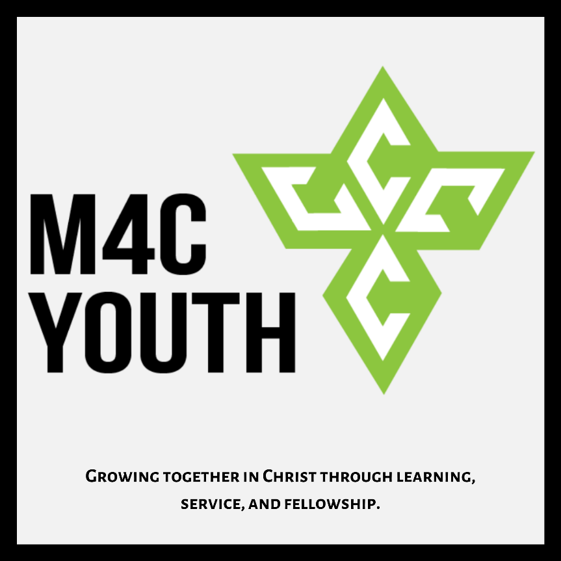

Youth group:

The first 3 Mondays of each month @ 6:30pm at the church.

6:30-6:45-Food and conversation.

6:45-7:30- Scripture lesson and discussion.

7:30-8:00- Games/hangout time.

Parents are more than welcome to stay and participate.

What We Learned:
Monday April 13th, we looked at the end of Matthew 19 where Jesus is approached by a rich young man and is asked how this man can gain eternal life. We discussed how the word “eternal” does not just refer to everlasting life, but also the fullness of life as well. This is true living that only God can bring. The young man had a hard time accepting what it takes to have this eternal life in Christ. It comes at a great cost, but the benefit exceeds the cost. Eternal life is not something that happens when we die, it is something that happens when we pursue Jesus. We experience eternal, full living now. Our challenge is keeping Jesus at the center of our hearts and minds.
Memory Verse of the Month:
“4 Rejoice in the Lord always. I will say it again: Rejoice! 5 Let your gentleness be evident to all. The Lord is near. 6 Do not be anxious about anything, but in every situation, by prayer and petition, with thanksgiving, present your requests to God. 7 And the peace of God, which transcends all understanding, will guard your hearts and your minds in Christ Jesus.” (Philippians 4:4-7)
COVID-19: We are posting our youth lessons online at the M4C Youth Group YouTube channel and sending out discussion questions for families to study together throughout the week. We are also doing Zoom chat meetings to check in with each other on the first 3 Mondays of each month until we can meet up again. Keep an eye out for an email from m4cnextgeneration@gmail.com for updates and details.
Please continue to pray for the leaders of our nation, states, cities, and churches as we navigate this odd time.

Coming up:
We will announce when we are able to meet up in person again. Jacob is planning some awesome youth activities for us to do together once we get the all clear.

Youth group is now the first 3 Mondays of each month.
We will have at least two teaching nights and a service night once a quarter. We will also be planning family hangout nights at least every other month.

Our Lessons are now on YouTube. You can find the link on the youth ministry tab of the M4C website.

All BBC events have been canceled for the time being.

We are looking for family volunteers to provide dinner for youth group whenever they can. If any families are interested just let Jacob know.

Summer Dates
June 13th-20th- SWAT High School Camp.
June 21st-26th- Junior High Camp (6th-8th).
June 28th-30th- First Chance Camp (2nd-3rd grade).
July 5th-10th – High School Camp (9th-12th).
July 12th-17th- Junior Camp (4th-5th grade).

Thank you for letting your family take part in youth group with us. We finish our lessons by 7:30-7:45pm and follow it up with a fellowship/hangout time until 8pm. If you would like to pick up your student earlier we wrap up the lesson by 7:30.

If you would like to learn more about what we are teaching, what events are coming up, or how you can get involved please feel free to reach out.

If you have any questions or concerns please feel free to text or call Jacob or Jenn.

Youth Leaders:
Jacob Hartman
Cell: (208)286-6433 Email: jah2334@gmail.com
Jenn McFarland
Cell: (208)670-1572

Youth Group Social Media
IG: @m4cnextgen
TikTok: @m4cyouth
YouTube: M4C Youth Group

