WE WILL BE TAKING PHOTOS AND VIDEOS TO SHARE WITH THE CONGREGATION AND ON OUR WEBSITE. IF YOU DO NOT WISH YOUR STUDENTS TO BE FEATURED IN THESE PHOTOS PLEASE LET US KNOW.

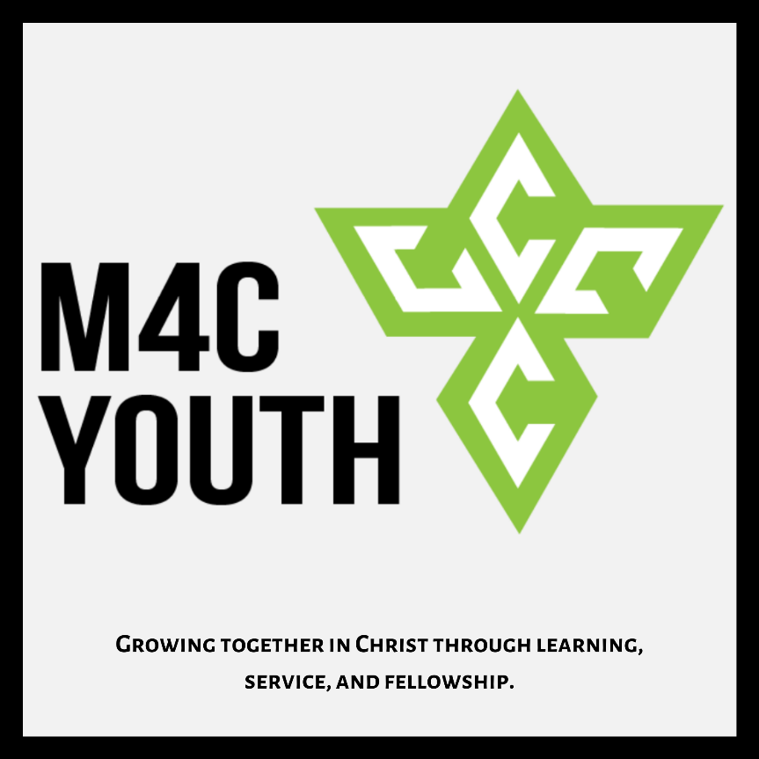

Youth group:

The first 3 Mondays of each month @ 6:30pm at the church.

6:30-6:45-Food and conversation.

6:45-7:30- Scripture lesson and discussion.

7:30-8:00- Games/hangout time.

Parents are more than welcome to stay and participate.

What We Learned:
Monday May 3rd, we looked at the first few stories in Matthew 21. We saw Jesus’ Triumphal Entry, Cleansing of the Temple, and Cursing of the Fig Tree. In each of these we see that the religious leaders and the crowds that approach Jesus, though they understand who He is, they do not understand what He is doing. To understand Jesus and His will, we need to continually be at His feet learning through His Word and prayer. When we do not spend this time with Jesus we begin to place our will above His or, even worse, act like our will is His.
Memory Verse of the Month:
“Trust in the Lord with all your heart and do not lean on your own understanding. In all your ways acknowledge Him and He will make your paths straight.” Proverbs 3:5-6

COVID-19: We are now able to meet up at the church building as long as we maintain the health standards laid out by the Governor. We will resume meeting the first 3 Mondays of each month for as long as we are still allowed to. For those who are still nervous about meeting in person we will still have our youth lessons on our M4C Youth Group YouTube channel. Keep an eye out for an email from m4cnextgeneration@gmail.com for updates and details.
Please continue to pray for the leaders of our nation, states, cities, and churches as we navigate this odd time.

Coming up:
Youth group is now the first 3 Mondays of each month.
We will have at least two teaching nights and a service night once a quarter. We will also be planning family hangout nights at least every other month.

Our Lessons are now on YouTube. You can find the link on the youth ministry tab of the M4C website.

All BBC events have been canceled for the time being.

We are looking for family volunteers to provide dinner for youth group whenever they can. If any families are interested just let Jacob know.

Summer Dates
As of May 4th it has been confirmed that camps are planned to continue as long things continue to improve with COVID-19. Final decisions will be made at the end of May for the final confirmation of camp.
June 13th-20th- SWAT High School Camp.
June 21st-26th- Junior High Camp (6th-8th).
June 28th-30th- First Chance Camp (2nd-3rd grade).
July 5th-10th – High School Camp (9th-12th).
July 12th-17th- Junior Camp (4th-5th grade).

Thank you for letting your family take part in youth group with us. We finish our lessons by 7:30-7:45pm and follow it up with a fellowship/hangout time until 8pm. If you would like to pick up your student earlier we wrap up the lesson by 7:30.

If you would like to learn more about what we are teaching, what events are coming up, or how you can get involved please feel free to reach out.

If you have any questions or concerns please feel free to text or call Jacob or Jenn.

Youth Leaders:
Jacob Hartman
Cell: (208)286-6433 Email: jah2334@gmail.com
Jenn McFarland
Cell: (208)670-1572

Youth Group Social Media
IG: @m4cnextgen
YouTube: M4C Youth Group

