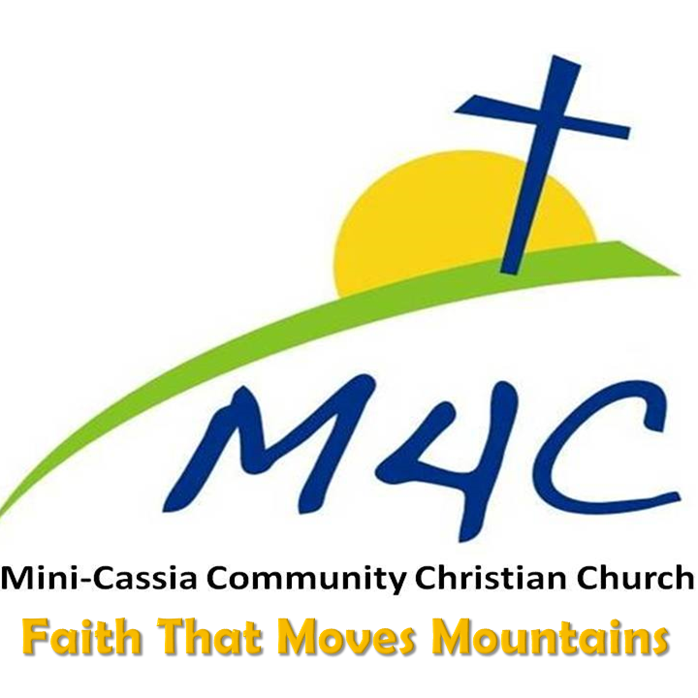
~~ Weekly Bulletin~~
September 19, 2021
=================== Questions or Needs? Please Call!
M4C Leadership
Pastor/Elder: Andy Morris 208-308-1620 amorris806@cableone.net
Next Generation Pastor: Jacob Hartman
208-286-6433 jah2334@gmail.com
Elders:
Jeff Heins 208-431-9819 jbrac@pmt.org
David Hruza 208-312-2493 hia@pmt.org
Worship Ministers:
Kim Turner 208-312-6482 kimmytuna@gmail.com
Lisa Hruza 208-312-2593 fawnwood8@live.com

Stay Connected
- Email @ m4cchurch@gmail.com
- Remind Texting App- Text
208-431-4127 to be added
- Facebook @ M4C Church
- Website- M4CChurch.org
- YouTube Live @ Mini Cassia Community Christian Church ~ Sunday @ 10:30
- WIFI password m4cchurch

Tithes & Offerings
Online Giving on M4C Website
m4cchurch.org click GIVE
(at the top of the page)
Bill Pay or Checks- Send to
M4C Financial Secretary:
Jeanne Larson, 2691 Fairmont Dr.,
Burley, Idaho 83318
Offerings & Attendance
September 5, 2021
Last Sunday: 95
2021 Average: 108
Needed Weekly: $3,397
Needed Monthly: $14,399
Last Week: $10,118.19
Month to Date $10,118.19
Mini-Cassia Community Christian Church (M4C) is non-denominational, meaning Christ is the recognized head of our church, not any person, group, or religious organization. M4C is self-governed and independent from any denominational control. M4C’s sole support is individuals within the church body giving financially and serving as acts of worship.

RightNow Media
Two ways to register & create an account.
https://www.rightnowmedia.org/Account/Invite/M4C, or text RIGHTNOW M4C to the number 41411 and you will be given instructions on how to sign up from your smartphone. This is a free gift from M4C to you! We are excited to see God use it to teach and grow His Church.

The Nursery and Kids4Christ children will be dismissed by the pastor after communion.

Upcoming Events
September 16 Women United @ M4C,
7-8:30 p.m. “Get to Know You Night!”
October 7-9 Middle & High School Youth Retreat @ Intermountain Christian Camp Contact Jacob for more information
October 9 Church Workday @ 9 a.m.
Fall cleaning inside, yard clean-up, etc.
October 16 The Old Testament (Not as hard as it looks!) 10-1 @ M4C ~ $7 with lunch! https://www.m4cchurch.org/special-events/
October 31 Harvest Party & Potluck @ M4C
More information to come

SERMON NOTES
__________________________________________________________________________________________________________________________________________________________________________________________________________________________________________________________________________________________________________________________________________________________________________________________________________________________________________________________________________________

Small Groups
Sunday School~Nursery – Adult-9:30 a.m.

Band of Brothers- 1st/3rd Tuesday
Wayside Cafe @ 6:45, Info~ David H.

Wednesday Women’s Bible Study
Jeanne Larson’s, 2691 Fairmont Drive, Burley @ 10 AM

Wednesday Family Friendly Life Group
@Turner’s, 35 W 110 Lane N, Rupert
5:30-8, Dinner & Bible Study

Youth - Wednesday @ M4C @ 6:30
RSVP to Jacob 208-286-6433

Wednesday Night Life Group- 7-8:30
@ Jeff Heins’ 112 E 300 N, Rupert

__________________________________________________________________________________________________________________________________________________________________________________________________________________________________________________________________________________________________________________________________________________________________________________________________________________________________________________________________________________

